10” and 12” Models Shown  What makes the S&S Fleshing Machine Great?  - Quality Safety Guards  - Quiet Operation  - Comfortable to use  - Easy Adjustments  - Quick 1 Tool Blade Changing  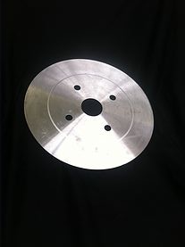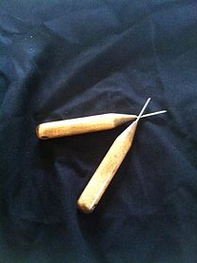  - 10” Easy Flesher= $1,050  - 12” Pro Series= $1,600  - New Blades= $67  - Regrind= $27  - Set of Steels= $22  - Repair Work= Quote  - Custom Table= Quote |  |  | What We Do  About Us  Here at True Cut Tool, Inc. we strive to be the best. All of our machines are built and manufactured in house in the state of Michigan. We offer not only the best fleshing machines on the market but we also service and repair any fleshing machine as well as regrind/resharpen any blade.  In addition to the fleshing machines and service work, we also provide customers with top of the line blade sales, tungsten sharpening steels and custom made tables for your machine.  *Lifetime Warranties available on certain models.  Contact Us  Phone: 1-231-832-7002  Email: info@fleshingmachine.com  Web: fleshingmachine.com  True Cut tool, inc.  5704 220th Ave.  Reed City, Michigan 49677 |  |  | True Cut tool, inc  5704 220th Ave.  Reed City, MI 49677  1-231-832-7002  - Only work with the Best!
Best Service in the Industry!  Here at True-Cut Tool, Inc. we are always brainstorming new ideas and ways to better suit all of our customers’ wants and needs. If you have a specific request, let us know! You shouldn’t have to settle for anything less than the best! |  |  | We offer some of the fastest turnaround times in the industry!  Once we receive your blade order for regrinding. They are usually completed and sent back within 48 hours.  Best fleshing machine on the market! Excellent service and quality all the way around! Keep up the AMAZING work! -Satisfied Customer |  |  | Pieces for assembly  All of our machines are assembled meticulously piece by piece. Everything is laid out and accounted for before assembly. Before shipment, we test run each machine to insure quietness and balance. Your machine will be inspected one more time before it is boxed and given a number.

